Full Paper Template for the 10th International Conference on FRP Composites in Civil Engineering in Istanbul, Turkey, 30 June – 2 July 2021

Name Surname¹, Name Surname², Name Surname³*

¹Affiliation, Centered , Italic, Times New Roman 10
²Affiliation if different from 1, Centered, Italic, Times New Roman 10
³Affiliation if different from 1 and/or 2, Centered, Italic, Times New Roman 10
*Corresponding author, only@email.tr, Centered, Italic, Times New Roman 10

Abstract
The abstract should be at least 150 words, but not exceed one page.

Keywords: List 4-5 keywords separated by commas and ending with a stop. (font size: 11 points, aligned: justify).

General Information

Paper size should be A4 (21.0 cm x 29.7 cm). Page margins should be 2.5 cm for the left, right, top and bottom margins. The full paper should not exceed 10 pages.
If you use this document as a master file for your paper, your paper should conform to the editorial guidelines formulated below.

Title, Authors, Affiliation

The title of the paper (Times New Roman, 14 points, bold, first capital of every word, aligned: center) can use a maximum of two rows. Leave one blank line between title and authors. Another line should be left free between authors and affiliations.
The abstract should be in Times New Roman 11, aligned: justify.
Leave three blank lines between affiliations and abstract, one blank lines between abstract and keywords.

Main text

Use ‘Times New Roman’ 11, single spacing, and ‘justify’ alignment for main text without indenting. Leave one blank line between the end of the text passage of a section and the following heading or subheading.

Headings and Subheadings

Use ‘Times New Roman’ 14, bold letters for main headings and leave one blank line between heading and text. Use first capital of the first word for headings.

Subheadings
Use ‘Times New Roman’ 11, bold letters for subheadings. Use first capital of the first word. Do not leave a blank line between subheadings and text.

Figures and Tables

General aspects
Figures and Tables can be placed within the text and must be cited before they are used in the text (Figure 1a and 1b).

Figures
Figures should be centre justified. Leave one blank lines between the text and the figure. In case the figure appears right on top of the page, do not leave a blank line. Do not leave a blank line between figure and figure caption. Leave one blank line between figure caption and next text passage or heading. Leave only one blank line between two consecutive figures or figures and tables. Example is given below.

Tables
Tables should be centre justified (Table 1). Table descriptions should be on top of the table with one blank line distance to the text or figure and table. Do not leave a blank line between table and table caption. Leave one blank lines below each table. Do not use font size smaller than 9.

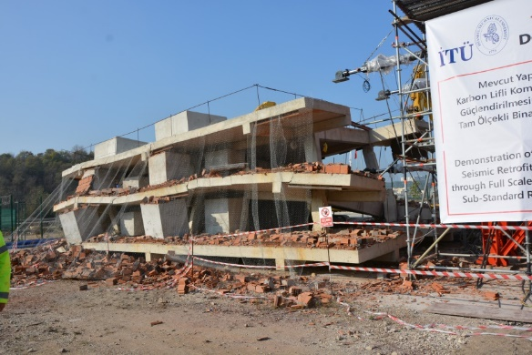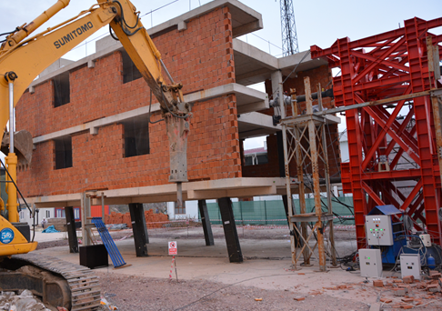
a) b)
Figure 1. Test buildings, a) collapsed reference building, b) deformed shape of FRP retrofitted building.

Table 1. Predictions of Euro code 8 Part 3 (2005) for tested specimens
Specimen | Series | L_{v}/h | κ_{a} | c | f_{fe} (MPa) | θ_{u} (%)
Reference | R20 | 3.42 | - | 0.03 | - | 2.6
One ply FRP Jacketing | R20 | 3.42 | 0.35 | 0.10 | 2972 | 3.3
Two plies FRP Jacketing | R20 | 3.42 | 0.35 | 0.14 | 2345 | 3. 8
Reference | R35 | 3.42 | - | 0.03 | - | 2.2
One ply FRP Jacketing | R35 | 3.42 | 0.35 | 0.10 | 2972 | 2.8
Two plies FRP Jacketing | R35 | 3.42 | 0.35 | 0.14 | 2345 | 3.2

Equations

Formulas and equations should be separated from the text (or figure/table) by one blank line before and after. Leave one blank line between two consecutive formulas and equations. In case a number of equations are used, provide numbering as in the example below. All equations must be cited before they are used in the text (Eq. 1). Cite the multiple equations as the following example (Eqs. 1-2)

A = B × C (1)

D = E + F (2)

Citations

Use the following examples for in-text citation. Silvia et al. (2001) studied the performance of infill URM wall systems retrofitted with FRP rods and laminates. Use the author's last name and the year of publication in the text (Biskinis and Fardis 2013, Teng et al. 2012, Haselton et al. 2008, Ilki et al. 2008, Euro code 8 2005, Teng et al. 2002).
Each reference shall be listed in a reference section as given in the example below. References should be listed alphabetically. Leave one blank line between two consecutive references.

References

Biskinis D, Fardis MN (2013) Stiffness and cyclic deformation capacity of circular RC columns with or without lap-splices and FRP wrapping. Bull Earthquake Eng 11:1447

Euro code 8 (2005) Design of structures for earthquake resistance, part 3: Assessment and retrofitting of buildings. European Committee for Standardization, Brussels, Belgium

Haselton CB, Liel AB, Lange ST, Deierlein GG (2008) Beam-column element model calibrated for predicting flexural response leading to global collapse of RC frame buildings. Report no. PEER-2007/03, Pacific Earthquake Engineering Research Center, College of Engineering, University of California, Berkeley

Ilki A, Peker O, Karamuk E, Demir C, Kumbasar N (2008) FRP retrofit of low and medium strength circular and rectangular reinforced concrete columns. Journal of Materials in Civil Engineering 20(2): 169-188

Silva PF, Myers JJ, Belarbi A, El-Domiaty K, Tumialan JG, Nanni A (2001) Performance of infill URM wall systems retrofitted with FRP rods and laminates to resist in-plane and out-of-plane loads. Proceedings of the structural faults and repairs conference, London, UK

Teng JG, Chen JF, Smith ST, Lam L (2002) FRP strengthened RC structures. Wiley, Chichester

Teng JG, Yu T, Fernando D (2012) Strengthening of steel structures with fiber-reinforced polymer composites. Journal of Constructional Steel Research 78: 131-143

